3 | P a g e

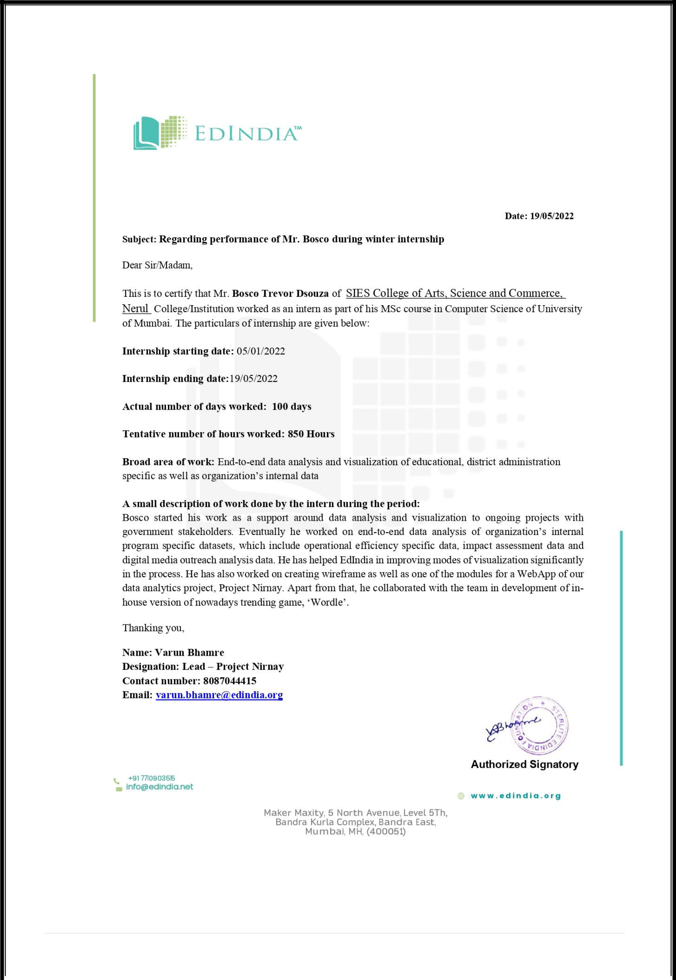

4 | P a g e

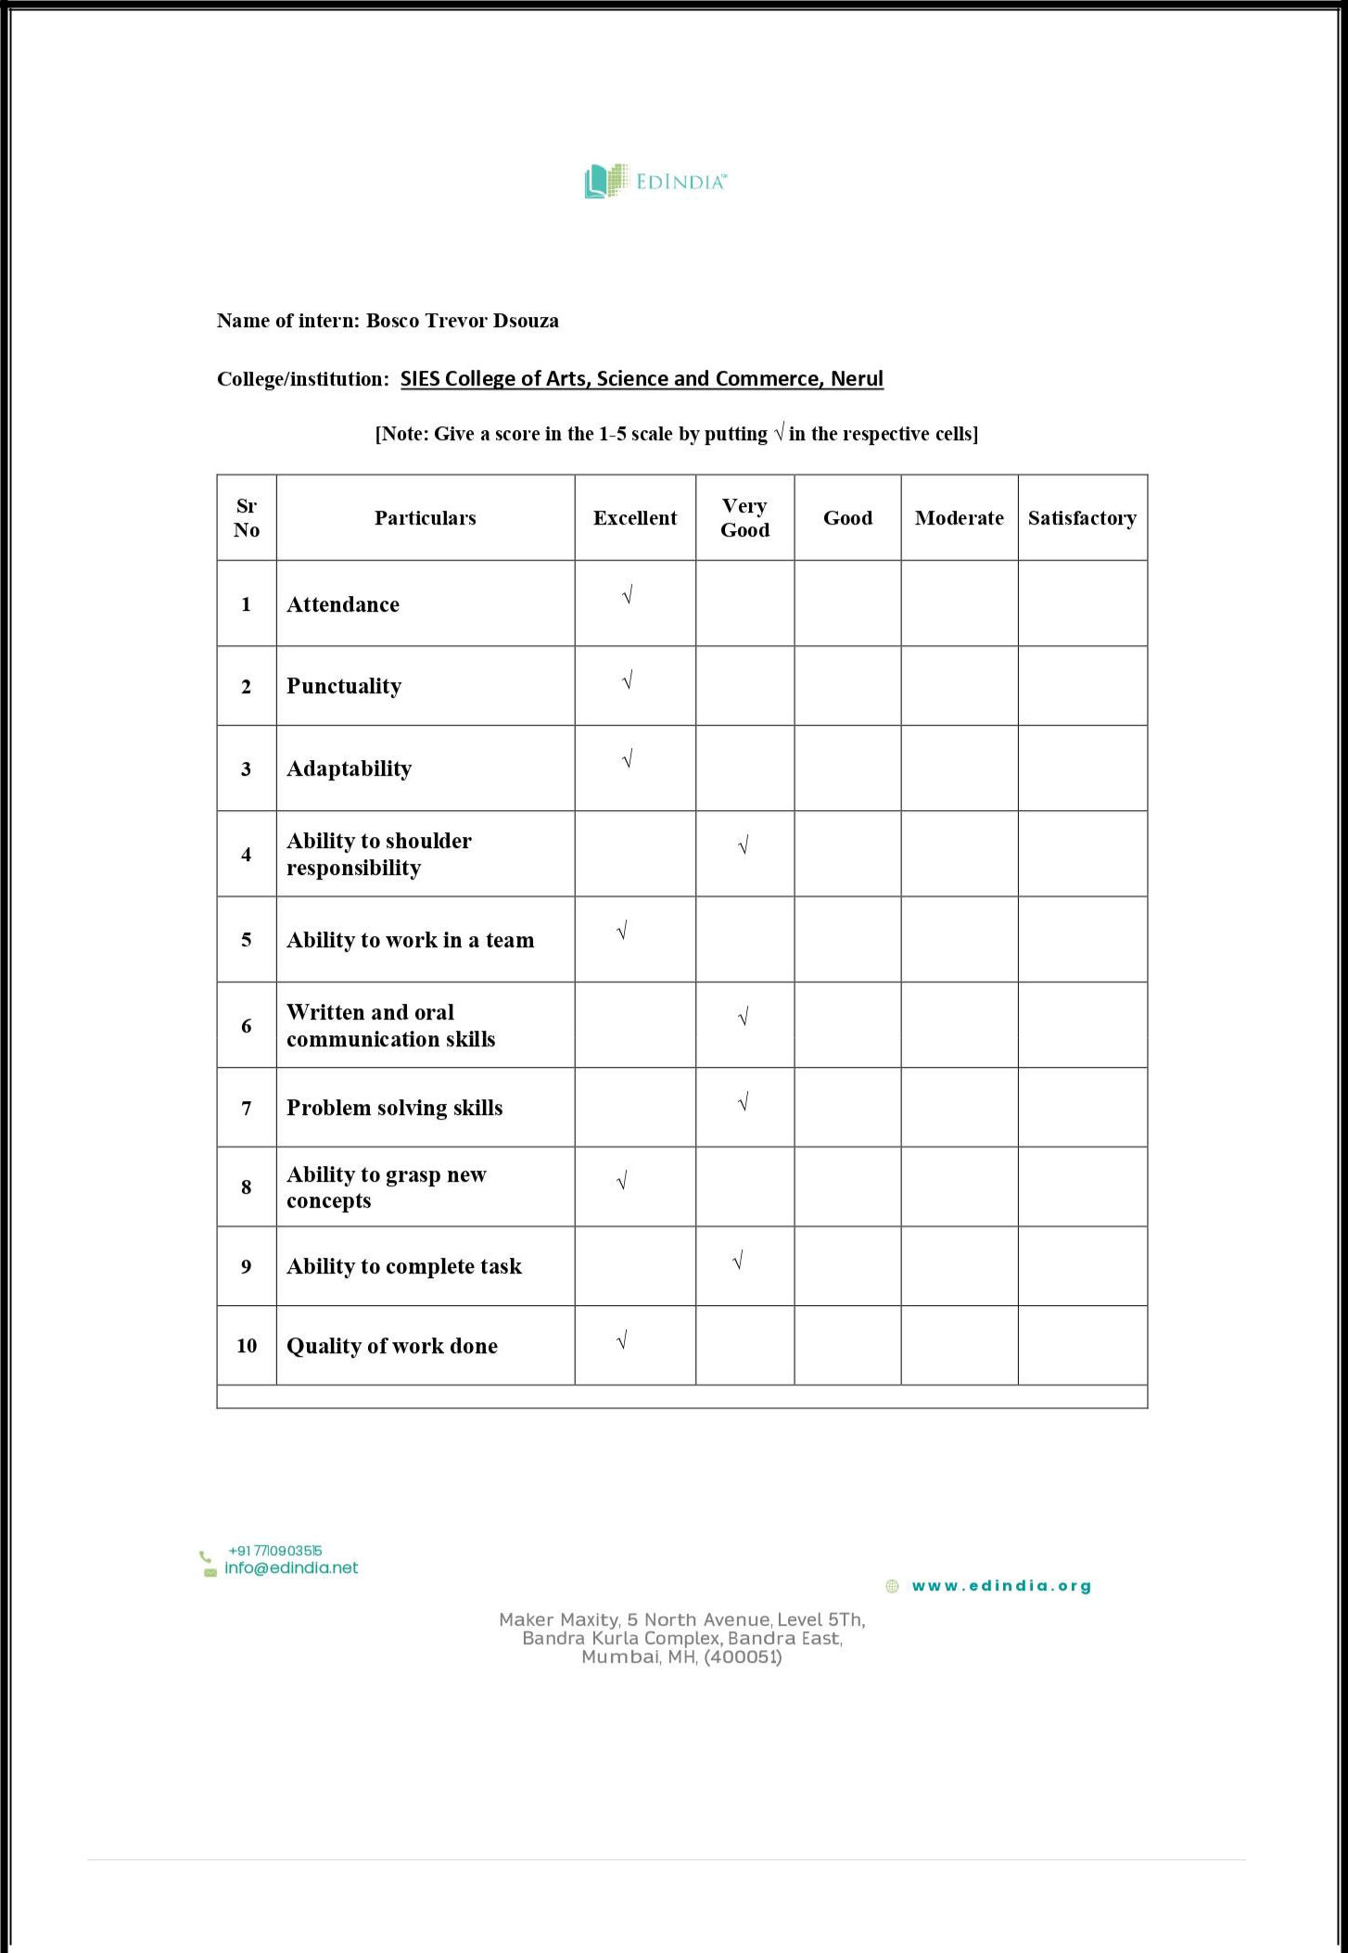

5 | P a g e

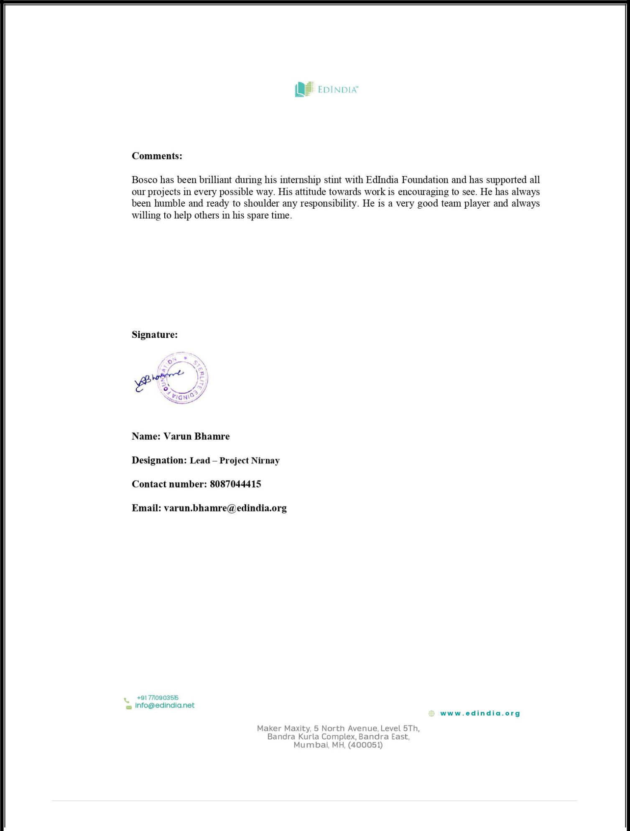

6 | P a g e

Table Of Content

Sr. No. | Topic | Page No.
1. | Title
 |  | 8
2. | Description of the organization | 8
3. | Description about the activities done by the
 | section where the intern has worked | 9
4. | Description of work allotted and actually done by | 10
 | the intern | 10
5. | Self -Assessment | 1

7 | P a g e

Title: Data Analyst Intern.
Description of the organization:

EdIndia is a section 8 Not for Profit Company that leverages technology and data analytics to create innovative solutions to impact the quality of education at scale. It has been provided incubation support by Sterlite Power Transmission Ltd. (SPTL) and its group companies. EdIndia is working with 6 states and providing analytical solutions to almost 53,000 schools and have trained almost 2,50,000 teachers.

There are 4 teams that function each having its own importance. Pragyan, Teachable, Digital Classroom and Nirnay.

Pragyan is a Multi-State In-Service teacher capacity building program that aims to improve the Teaching-Learning environment in the classrooms to capacitate the teachers of public education systems of the country, Pragyan focuses on Large-Scale interventions leveraging technology. It mainly deals with E-content creation and Teacher support.

Teachable is basically to support and provide webinars for the students who are pursuing or want to pursue their career in teaching.

Digital Classroom looks after the student’s assessment, teacher training and conducting live sessions and webinars.

Nirnay All the analytical part is looked after by team Nirnay. All the data is sent to Nirnay team so that they can generate meaningful insights and present it in a dashboard format. Also, with dashboard we provide some statistical insights.

Nirnay also works with administrative level of data that is government related data with respect to electricity connection, drinking water connection, type of roads, etc.…

So, I was a part of team Nirnay and I worked as a data analyst.

Recent project that we have acquired are:

- MTGSY (Mukhyamantri Tripura Gram Sammridhi Yojana) project of South Tripura.

- Vidya Jyoti 100 School Yojana

- Hamara Vidhyalaya school level data with students’ assessment (Namsai)

- Sephaijala district Basic Survey project administrative level of data

8 | P a g e

Description about the activities done by the section where the intern has worked:

Google Data Studio:

A Business Intelligence tool or an analytical tool used to represent visualization on a dashboard and create an interactive dashboard. We can create are own dashboards and embed those dashboards in are website. We can also perform calculations and other operations. We can also implement map graphs to give a better location specific distribution or result to the user.

Advantage:
- It is easy to use.
- It has many connectors to connect directly with data source.

- Consist of a tons of community visualization.
- It is a 100% free source.

Google Spreadsheets:

The data from the stakeholders come in a spreadsheet format. All the operations and all the file cleaning are done in the spreadsheets.

Advantage:

- It is easy to use.

- It comes with a huge list of formulas that can be very helpful to perform operations and in manipulating the data as per the requirements.
- It is a 100% free source.

Google BigQuery:

The data is also collected in real time and in such case spreadsheet will not be able to hold that amount of data in such a case we need a warehouse to store the data. So, Bigquery is one of the best options.

Advantage:

- It is easy to use similar to SQL.

- It allows you to use 10GB of free data.

Python:

I worked with python to clean data and also perform some statistical insights with the help of SciPy library and plotting those insights with the help of matplotlib and seaborn

9 | P a g e

Description of work allotted and actually done by the intern:

I started working with support around data analysis projects and tried to involve myself in maximum number of projects to get maximum exposure. So, I have developed dashboards with respect to administrative data, student assessment data, and Internal purpose data which consist of data from various digital platforms.
Work description:
- Week 1

  - First week the first two days was like training they gave me some dashboards and ask me my views like third person review.

  - After that my first task was to modify the Sephaijala district basic survey dashboard.

  - After which my next task was to find out new visualizations to implement in the dashboards.

  - The next task was to develop a automated data cleaning model which can highlight the errors and null values in an excel file.

- Week 2

  - In Second week of Internship, I was asked to do my very first dashboard that is to make a dashboard to track the progress of the internal field visit team of Nirnay.

  - It took me around three days to create a dashboard and clean the data.

  - After that there were some issues in the date format of the dashboard which I modified.

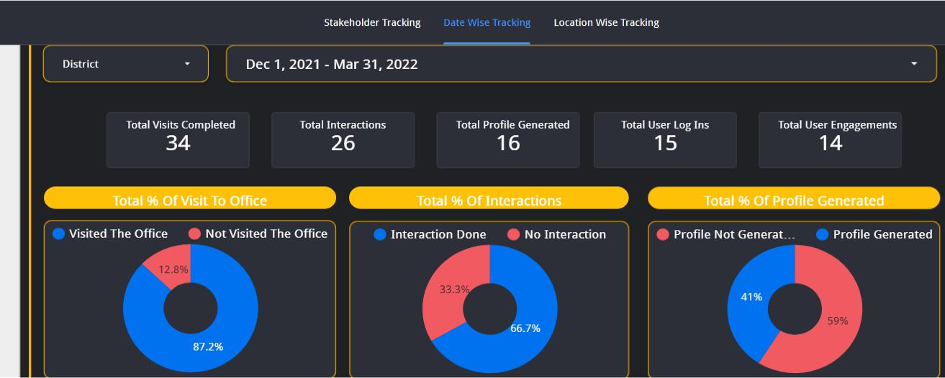

10 | P a g e

- Week 3-4

  - In This week I created a dashboard around the Teachable Students intake data.

  - This involved collecting data from pdf format and then converting it into excel format.

  - The next step was to create a dashboard around it.

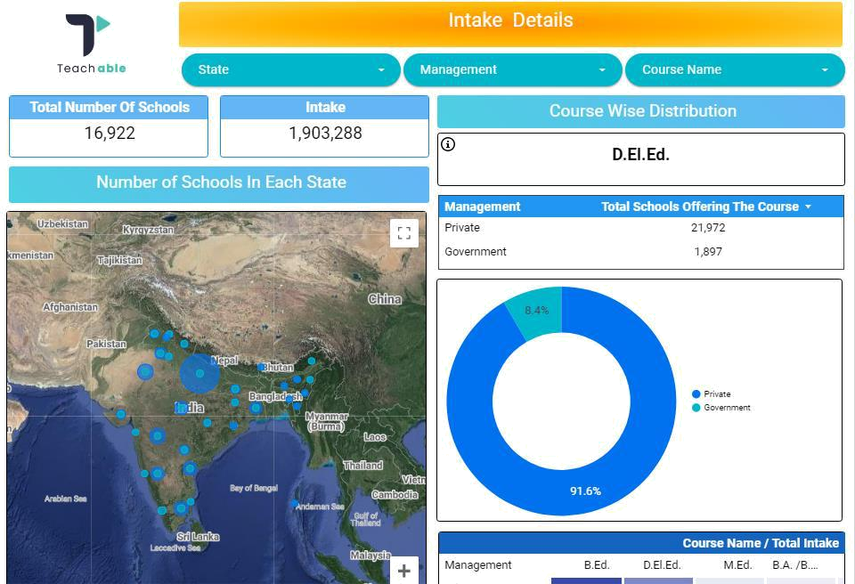

- Week 5-6-7

  - I worked with creating a dashboard template for Namsai Hamara Vidhyalaya dataset and then helping with the observation and dashboard creation.

  - I also helped in modification of the new Sephaijala dashboard.

11 | P a g e

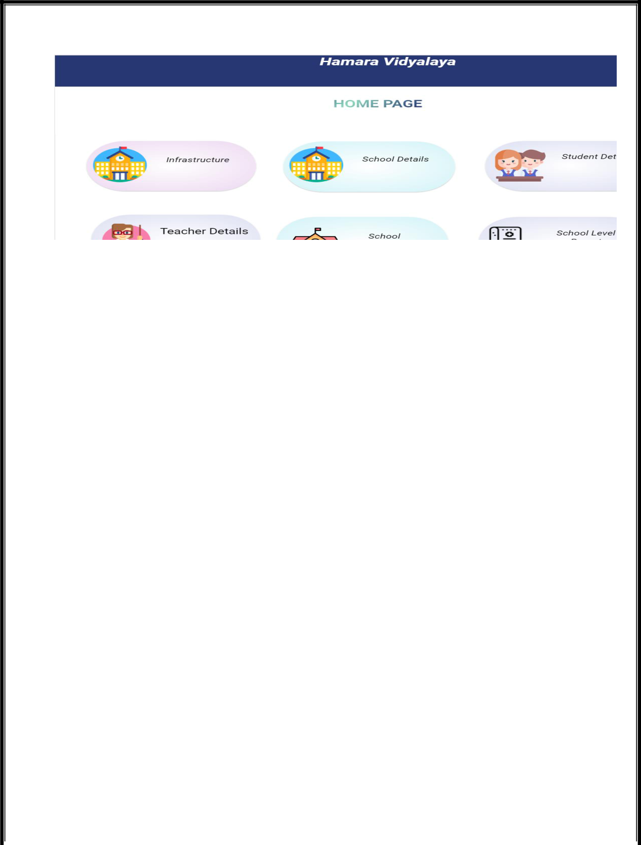

- Week 8-9-10-11

  - I collaborated with the team in creation of an education related wordle game for teacher engagement and to boost their interest in education.

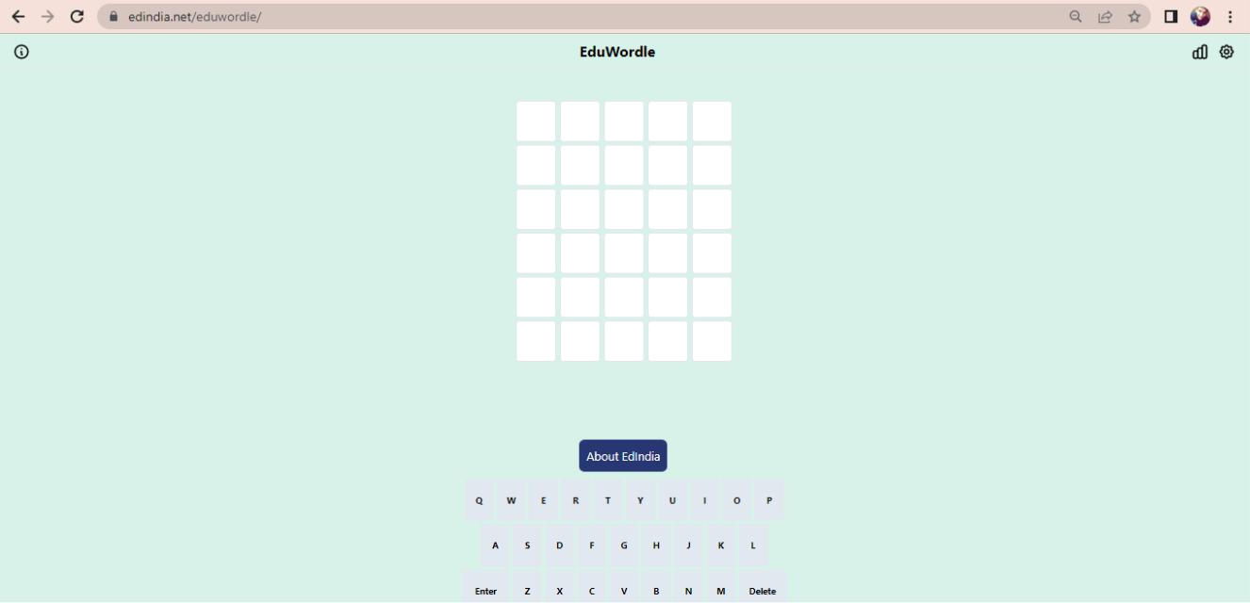

- Week 12-13

  - Created a dashboard around the MTGSY dataset for administrative level Tripura data.

  - Created a wireframe for the Nirnay web application.

12 | P a g e

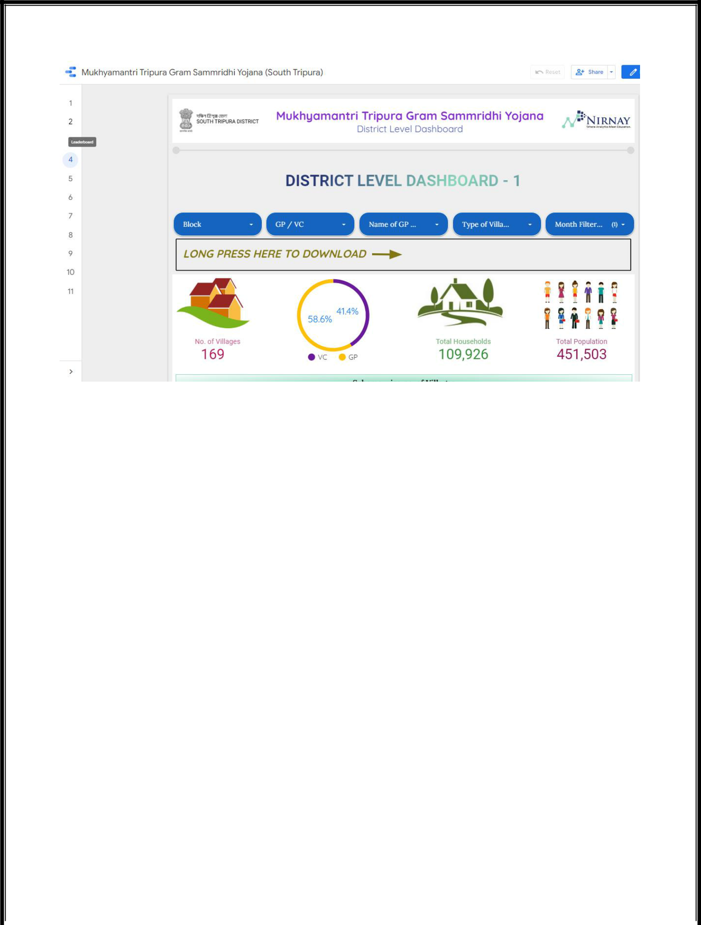

- Week 14-15

  - Collaborating with my team I developed a Vidya Jyoti School CBSE board dashboard sample which helped us to impress the stakeholders and gaining that project.

  - I also also created a dashboard around students’ dropout rate from

Tripura district.

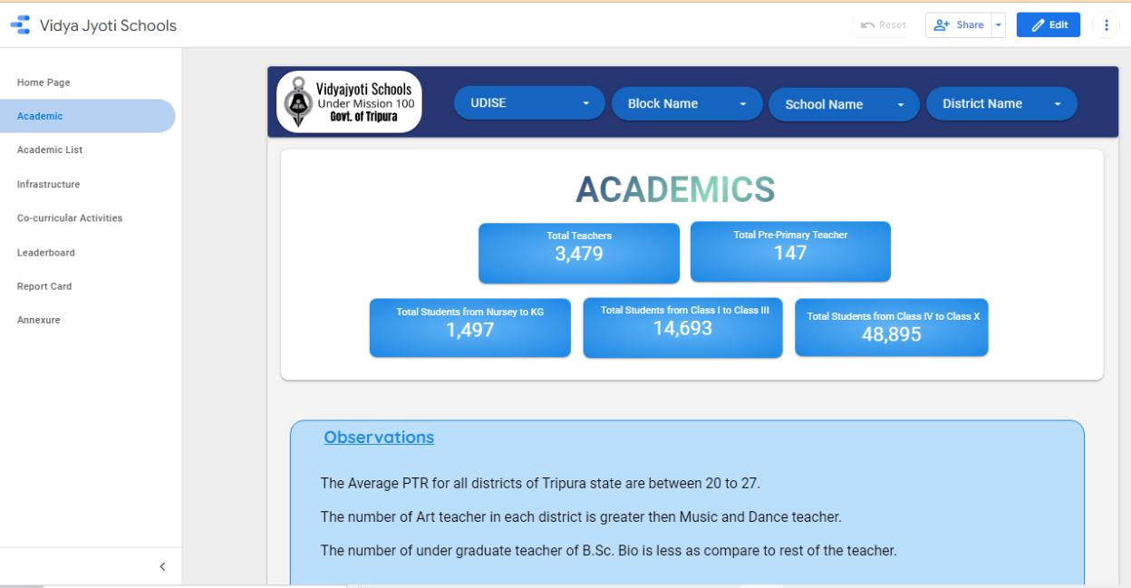

13 | P a g e

- Week 16-17-18

  - Created dashboard for Tripura student baseline dataset which is internal assessment of students based on two subjects which is English and Math.

  - Created a dashboard around Pragyan YouTube data, Pragyan Teacher assessment and Ranking data, Pragyan Mobile App Engagement data and Pragyan Field Visit Tracking data.

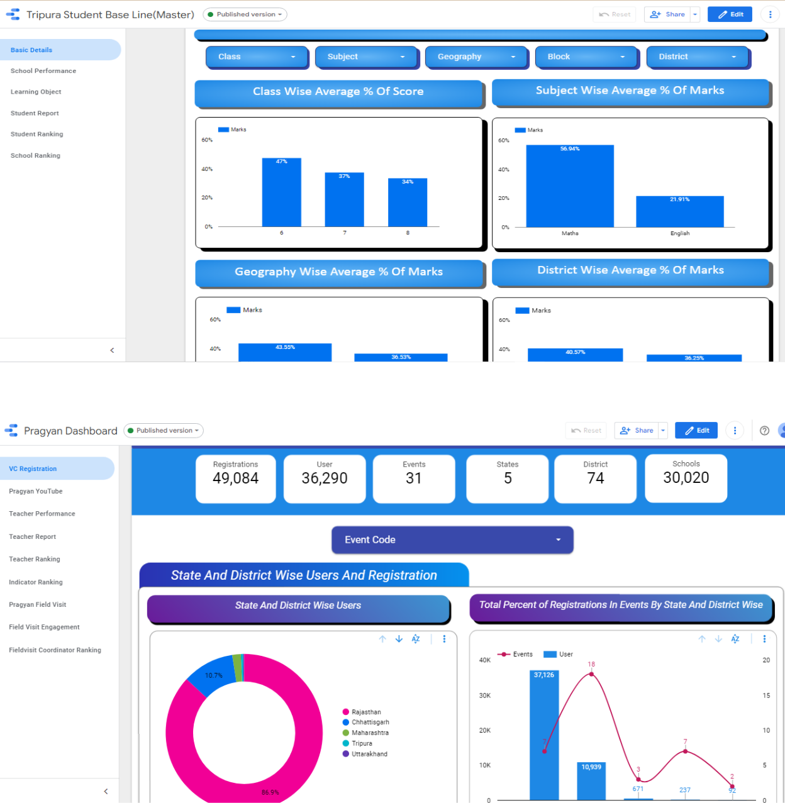

14 | P a g e

- Week 19-20(Extended Contract)

  - In my extended contract period, I was given the task to create an input model front end for data collection.

  - I was also given the task to develop a story like dashboard.

  - I also gave observation based on the insights.

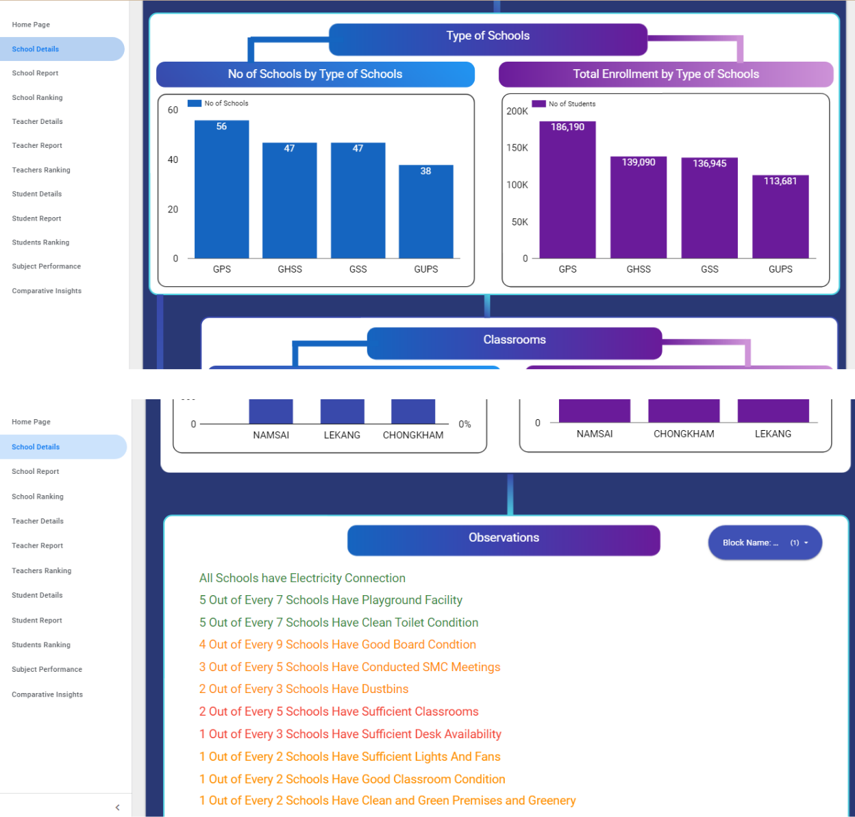

15 | P a g e

Self-assessment :

During this internship I learnt many things like react.js, python, Flask, Google spreadsheet, google Bigquery, postgres SQL and google data studio. I developed a soft skill to work with a team and how to effectively manage time. As a data analyst I think I developed one of the most important skills that I represent data in a story format.

Self-learning has always left a positive impact on me, as it gives me confidence to achieve something on my own. There are so many new things to learn and there are also lot of resources available, the key is to be patient and give some time to learn things. Industry experience made me realize that every person needs to go beyond his/her syllabus because syllabus always lack what industry is already working with. I got to work in a team which improved my communication skills.

I am grateful towards Mr. Varun Bhamre, at EdIndia Foundation and the entire team of Nirnay for providing guidance and also for helping me whenever I had queries. I achieved an experience which definitely made change in my life, work style and personality as well

16 | P a g e

